# Exercise 1: Precipitation and QGIS

## Introduction

Most NASA Earth observation data, including precipitation and soil moisture, is available in HDF5 file format. [Giovanni](https://giovanni.sci.gsfc.nasa.gov/giovanni/) allows users to access NASA Earth data in more formats, including NetCDF and GeoTIFF. NetCDF and GeoTIFF are both formats that can easily be used in GIS applications. This exercise will use QGIS, since it is an open source GIS program.

## Objectives

By the end of this exercise, you will be able to:

* Subset, analyze, and download GPM IMERG precipitation data using
  + Giovanni, the Precipitation Measurement Missions (PMM) - the Precipitation Processing System (PPS) data archives
* Import precipitation data into QGIS

## Part 1A: Subset and Analyze GPM Daily Precipitation Data Using Giovanni

**Case Study: Heavy Rain in California During January 2017**

* Go to Giovanni: <http://giovanni.gsfc.nasa.gov/giovanni>
* On the Giovanni page you will see the following options:
  + **Select Plot:** allows selection of analysis options
  + **Select Data Range:** allows selection of a time period
  + **Select Region (Bounding Box or Shapefile):** allows selection of a geographic region by latitude-longitude, map, or shapefile
  + **Keyword:** Search data parameter by keyword
  + 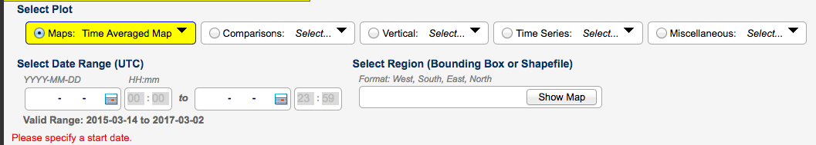**Plot Data:** located on the bottom right of the page, starts action to make desired plot

Enter the following options:

* **Keyword:** 
  + Enter IMERG, then click **Search**
  + 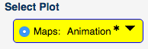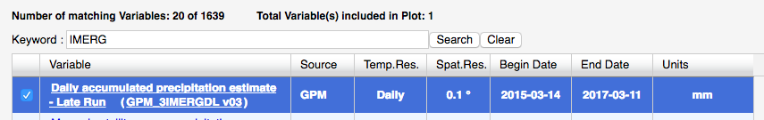Select Daily IMERG – Late Run, Daily Accumulated Precipitation
* **Select Plot** 
  + Next to **Maps**, select **Animation**
* **Select Region (Bounding Box or Shapefile):** 
  + 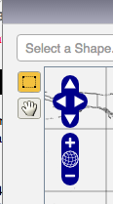Select **Show Map**
  + Draw a box, zoom in, and pan the map using these icons
  + Draw a box around California, or enter longitude-latitude:

-136.0,32.0, -114.0,44.0

* + - Note: west longitudes and south latitudes are negative, whereas east longitudes and north latitudes are positive
  + Click on **Show Map** to see the region
* **Select Date Range (UTC)**
  + Enter 2017-01-06 and 2017-01-11 for January 6-11, 2017
  + Click on **Plot Data** (at the bottom right of the screen)
  + After a few minutes, you will get an animation window
* Observe the animation a few times, then step through the frames one at a time
* You may want to use **Options** (on the top right) to change the scale

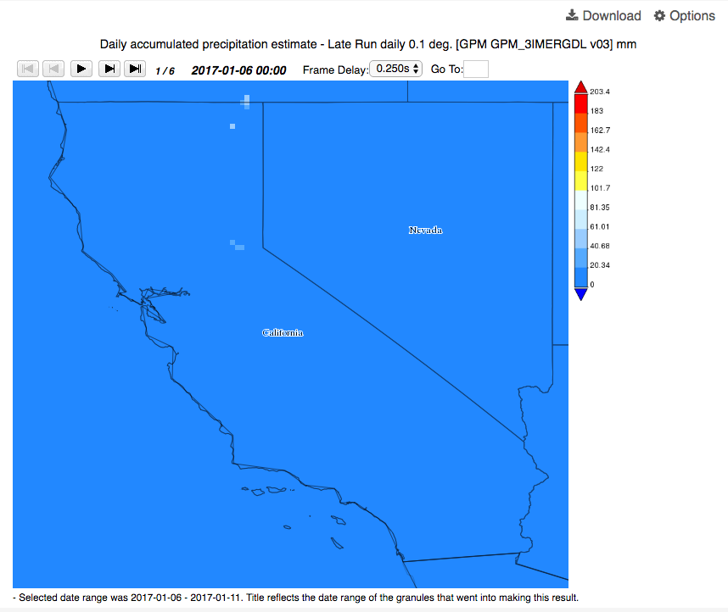

**Options** allows for choosing scale and colors

Frame control and selection

Start animation

Step through frames

* **Based on the rainfall animation, answer the following questions:**

1. Note down the date when the rain system first arrived over California from the Pacific Ocean
2. From the color table on the right, note down the maximum rainfall range (e.g. 100-150 mm or >150 etc.) for this date
3. How does the rain system move (approximate direction) after this date over the state of California?

## Part 1B: Accumulated Rain from January 8-10, 2017 Over California

* Click on **Back to Data Selection** on the lower right-hand part of the screen
* 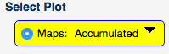Select the same IMERG data as in Part 1A: **Daily Accumulated Precipitation Estimates – Late Run**
* **Select Plot:** Select Maps: Accumulated
* **Select Region (Bounding Box or Shapefile):**
  + Click on **Show Map** and Enter **California** for the Shapefile

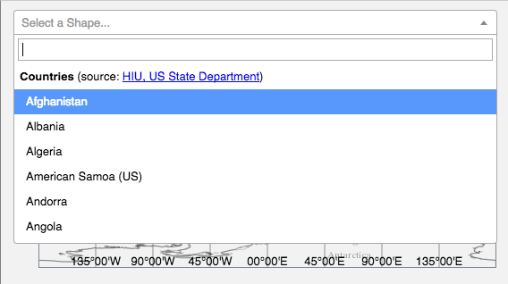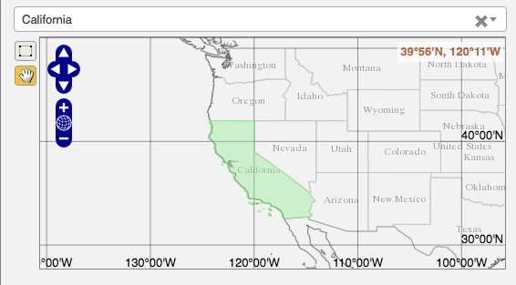

* **Select Date Range (UTC):** 
  + Enter 2017-01-08 and 2017-01-10 for January 8-10, 2017
* Click on **Plot Data** on the bottom right
* You will get a three-day accumulated rain map over California

1. 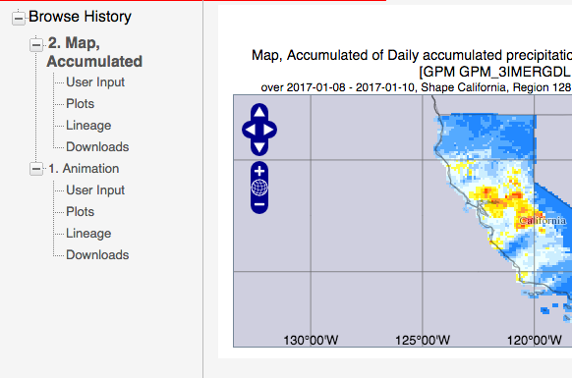Where do you see the areas with rainfall > 200 mm (approximate latitude-longitude)?

* 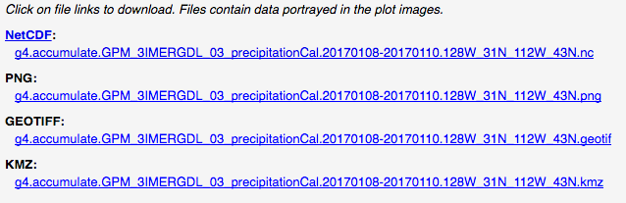On the left you will see a list of options with **Downloads** options
* Click on **Downloads**
* You will get links to the files as shown above
* By clicking on each link, you can save each file on your computer
* Click on the **NetCDF file** and save it on your computer
* Click on the **GeoTIFF file** and save it on your computer
  + Note: Both NCDF and GeoTIFF files can be imported into QGIS
* To view the KMZ file, you will need [Google Earth](https://earth.google.com/download-earth.html) installed on your computer

**Part 1C: Precipitation Time Series**

**Plot a Time Series of IMERG Late Half-Hourly Rain Rates Averaged over California for January 8-10, 2017**

* Click on **Back to Data Selection** on the lower right-hand side of the page
* Go to **Keyword** and enter **IMERG Late**
* Choose the **Multi-satellite precipitation estimate with climatological gauge calibration – Late Run** for half-hourly rain rate data
* **Select Plot:**
  + Choose **Time Series: Area-Averaged**
* **Select Region (Bounding Box or Shapefile)**
  + Choose the California Shapefile as in Part 1B
* 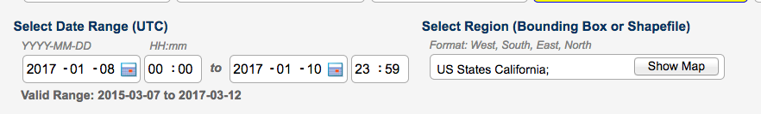**Select Date Range (UTC)**
  + Enter the dates from 8 January 00.00 hour to 10 January 23.59 hour
* Click on **Plot Data** (at the bottom right)
* You will get a half hourly time series for three days (January 8-10, 2017)
* You can save this image by clicking on **Image** on the top right
* 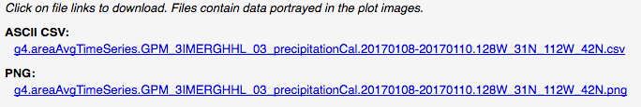Click on the **Downloads** link on the left, and you will see the following options:
* 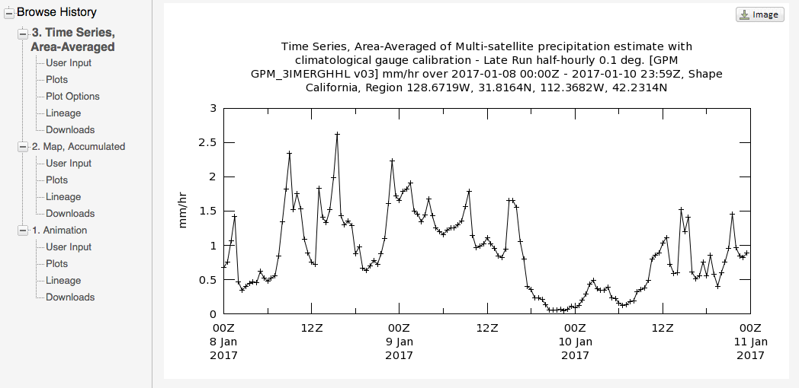In addition to the .png image, you can download the time series as a csv file to view in Excel

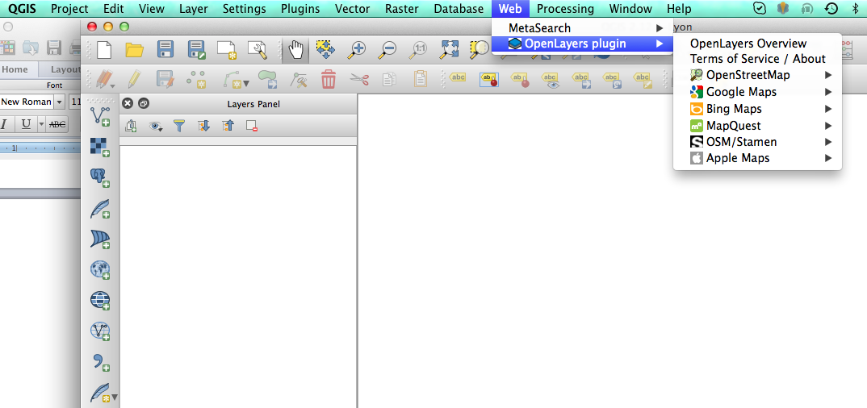

* **Based on the time series, write down the following:**

1. Date and time for the maximum rain rate (see the csv file to get this information):
2. Maximum rain rate (with units):

## Part 2: Import IMERG Precipitation into QGIS

* Open QGIS on your computer
* From the top menu bar click on **Web**, select **Open Layer Plugin** and select a background map
  + This exercise uses the plugin **OpenStreet Map**
* Import the IMERG data using the **Add Raster Layer** button 
* Select the **NetCDF** file you saved on your computer from **Part 1B: Accumulated Rain January 8-10** (file type: .nc)
* 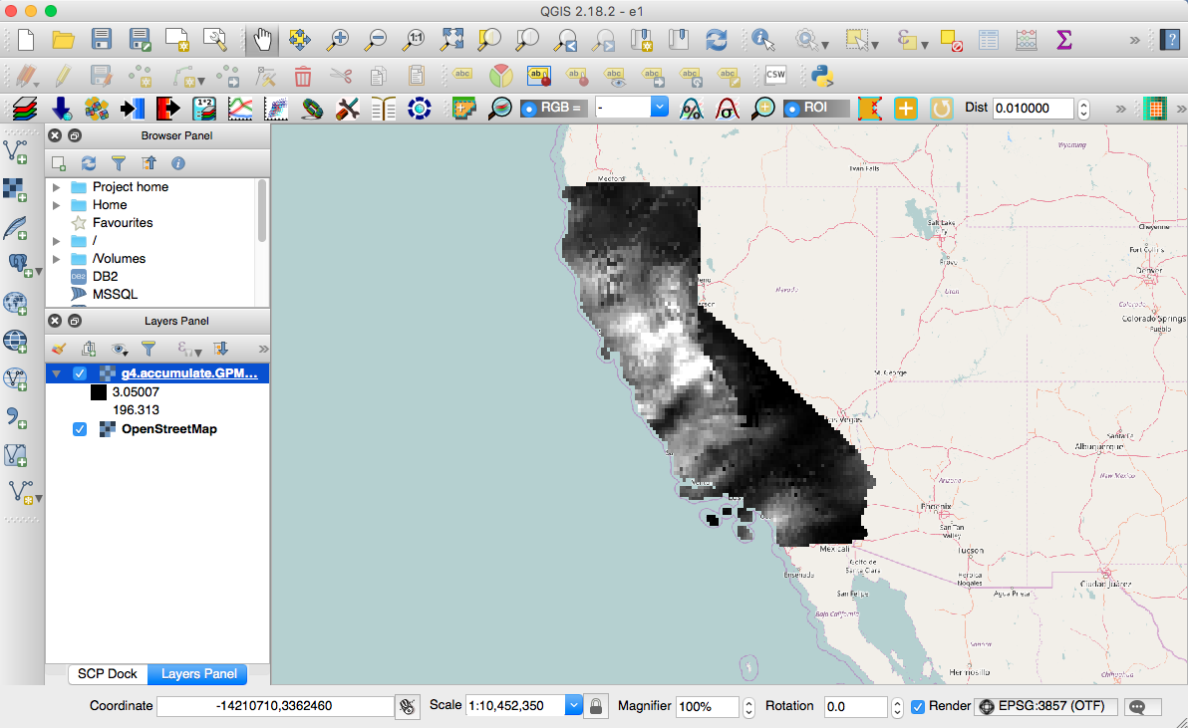You may have a **Coordinate Reference System Selector** box pop up. Set your coordinate reference system to NAD83.
* You will see the raster layer displayed on the map. Zoom in on the layer using the top menu bar on the window
* Click on **Layer** in the top menu bar and select **Properties** to edit the map visualization and analysis
* From the left side menu, select **Style**
* In **Render Type**, select **Singleband pseudocolor**
* Choose a color table from **Generate new color map**
* Set **Mode** as **Equal Interval**

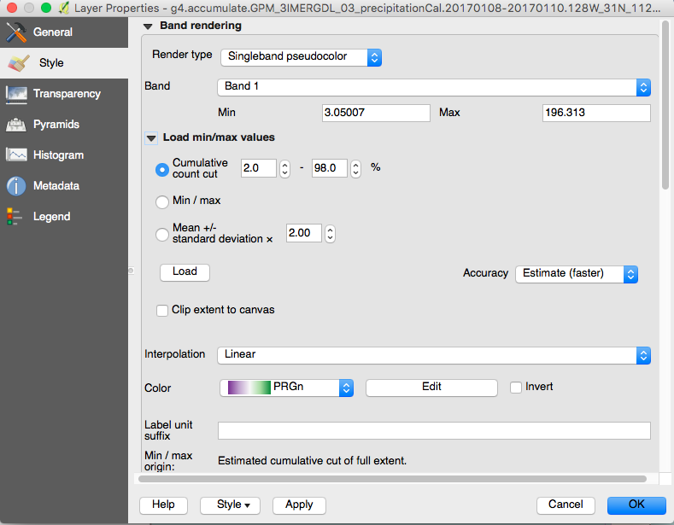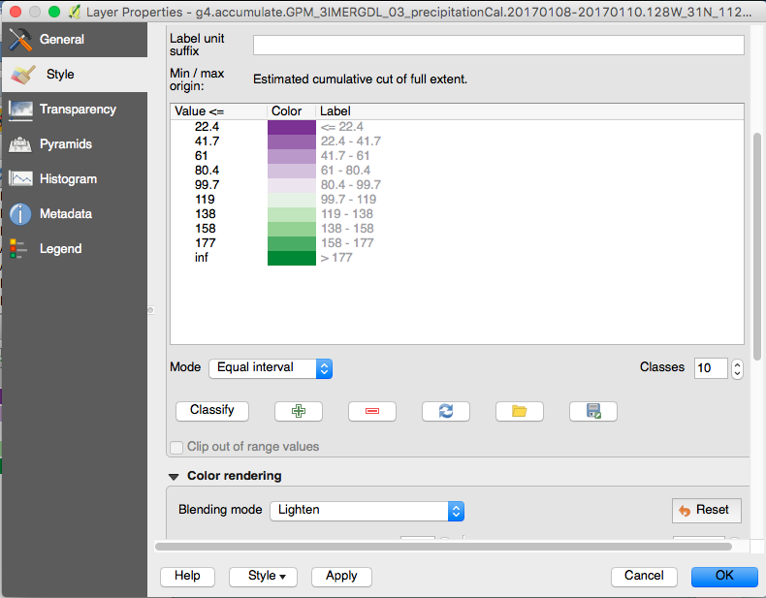

* Enter 10 intervals in **Classes**
* Click on **Apply** and **OK**
* Finally, from the left side menu, select **Transparency** and choose the appropriate percent (50%) value of transparency to see the OpenStreet Map under the precipitation layer
* You will get the precipitation map shown below:

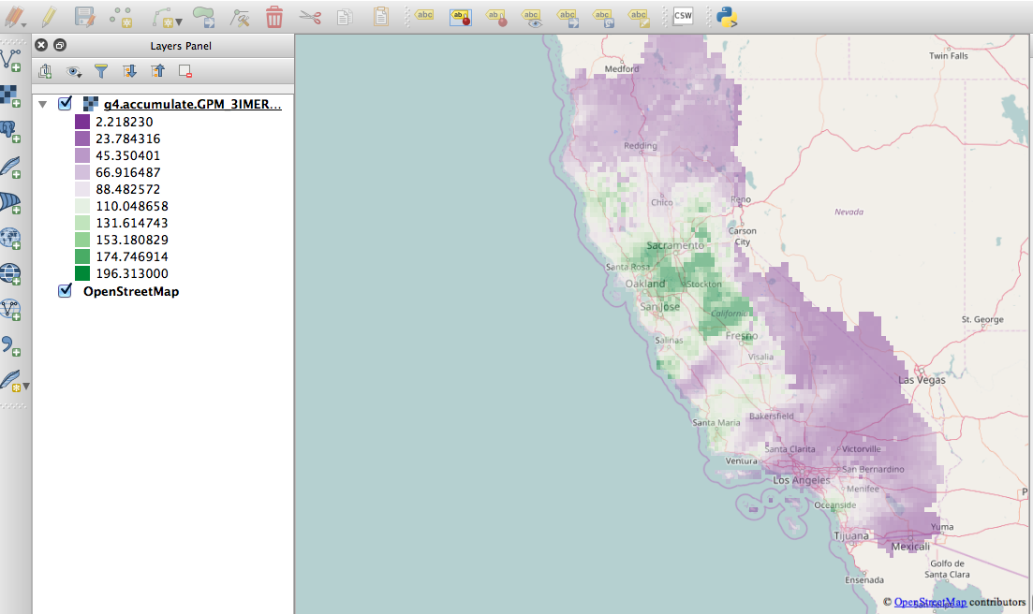

Accumulated Precipitation Values

* Zoom in on the map and write down the name of the cities with heavy rainfall (>150 mm)

## Part 3: Download IMERG Data in HDF5 Format from PPS

* Go to the PMM access page: <https://pmm.nasa.gov/data-access/downloads/gpm>
* This site requires user registration via email
* You will see all the GPM data (Levels 1, 2, and 3) available on this page
* 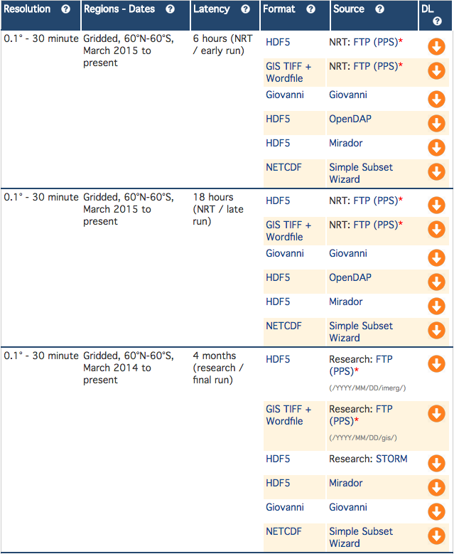**Level 3** shouldbe selected by default
* Scroll down to see the IMERG data table
* You will see many options – scroll down to **the NRT/late run data**
* Many formats and source options are available
* This exercise focuses on downloading an **HDF5 file**
* The last column shows an arrow for **DL** (download)
* Choose the first option and click on the **DL** arrow
* You can register now if you have not so far
* You can also sign in with your email for both username and password
* Once you login, you will see the IMERG Late directories by YYMM
* Go to **201701** for January 2017
* You will see links to all the IMERG half-hourly files
* You can download them all by clicking on the links
* Select the file that corresponds to the day, hour, and minute for the maximum rain rate in the time series from Part 1C.
* Click to download and save this HDF5 file on your computer
* You will use a Python script this afternoon to read this file

## Optional Activity 1

* Go back to the Level 3 data table – the download options also include Giovanni and Mirador. At your convenience you can explore all the sources available for downloading data.

## Optional Activity 2: Giovanni

* Instead of **Daily Accumulated Precipitation Estimates** in Part 1A choose the half-hourly rain rate as in Part 1C
* Choose the date when the rain system moved over California and animate using the same procedure as in Part 1A, but by adding HHMM (00.00 to 23.59) to the **Date Range**. This animation will show 48 frames and how the rain extent changed during the day.